User Acceptance Testing (UAT) Document
Project Name: FareOS - Series Fare Booking System
Prepared By: Ecogo Software Solutions Pvt Ltd
Version: 1.0
Client Name: Moudut Mahabur Rahman
Date: July 15, 2025

1. Objective
This document defines the UAT scope, test scenarios, and sign-off process for the FareOS Series Fare Booking System. The goal is to ensure the system meets user requirements and is ready for production deployment.

2. Scope
The FareOS Series Fare Booking System enables travel agents and administrators to manage group and series bookings efficiently. It supports fare search through standard, filter, and calendar views, and offers tools for booking management, fare creation with seat tracking, and fare split-up handling. The system also includes staff and agency management, credit request approval, and a news module for broadcasting updates. With role-based access and a user-friendly interface, it ensures smooth operations for all users.

3. UAT Team
Role | Name | Responsibility
UAT Lead | Farhana Liyakath | Coordinate testing
QA Tester | Nazria | Execute test cases
Product Owner | Sabeel C | Final approval
Developer | Shabin | Bug fixes

4. Entry Criteria
- Development complete
- Unit & integration testing passed
- UAT environment deployed
- Test data prepared

5. Test Cases & Scenarios
Module | Test Scenario | Expected Result | QA Result (Internal) | QA Result (Client)
Fare Search View | User searches fares by one-way/round-trip and sees booking list. | Relevant fares are listed and bookings visible. | Pending | Pending
Filter View | User applies filters to refine fare search. | Fares displayed based on applied filters. | Pending | Pending
Calendar View | User checks fare availability on a calendar layout. | Calendar view displays daily available fares. | Pending | Pending
Live Bookings | User views live bookings with filtering options. | Booking list shown with filters and details. | Pending | Pending
Fare Management | Admin views and edits existing fare entries. | Fare list loads correctly with edit options. | Pending | Pending
Add Series Fare | Admin adds a new series fare with flight data. | New fare saved with all entered info. | Pending | Pending
Staff Management | Admin manages staff list with edit/delete. | Staff records saved and actions functional. | Pending | Pending
Agency Management | Admin views, approves/rejects agencies. | Agencies updated with approval status. | Pending | Pending
Credit Request Management | Agency submits credit, admin processes it. | Credit reflected with correct status. | Pending | Pending
News & Updates | Admin creates and publishes agent news. | News is visible and editable by admin. | Pending | Pending
AirIQ Integration | System fetches and displays fares from AirIQ API | AirIQ fares are displayed and processed accurately | Pending | Pending

7. Sign-Off
Role | Name | Date | Signature
QA Lead | Nazria | 09/07/2025 | 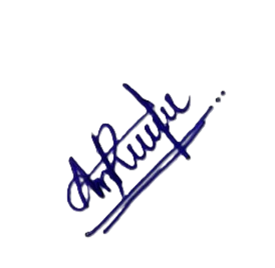
Project Manager | Sabeel C | 09/07/2025 | 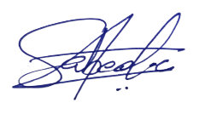
Product Owner | Sidheeque

